PITTWATER GOLF CLUB INC.  ALL COMMUNICATIONS TO HON. SECRETARY:  P.O. Box 330, Rosny Park TAS 7018  Email: pittgolf @bigpond.net.au  Internet: pittwatergolfclub.com  Ph: (03) 62652069  ABN 76 022 314 203 – Registered for GST | 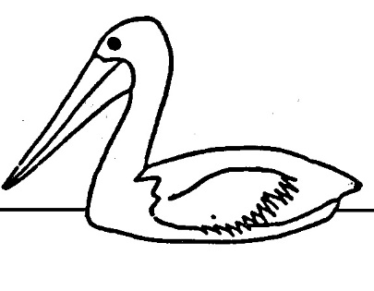

APPLICATION FOR SOCIAL MEMBERSHIP

I, Mr/Mrs/Ms/Miss
First Name Middle Initial Surname (Please Print)

of
Full Postal Address Post Code
apply for social membership of the Pittwater Golf Club Inc. and if my application is approved I agree to be bound by the Constitution and Rules of the said Club, a copy of which can be found on the above website.

Signed: Date:

DETAILS REQUIRED

Occupation: Employer:

Telephone: (Home) (Work) (Mobile)

Email Address:

Proposer: Seconder:
Print Name Print Name

Signature: Signature:

Application Approved: Date:

MEMBERS: Nomination Deposit….NA
Annual Subscription…$50.00

Hon. Secretary (01.01.2022)
PITTWATER GOLF CLUB INCORPORATED
pittgolf@bigpond.net.au
PO BOX 330, ROSNY PARK, TAS, 7018

NOTICE TO ALL MEMBERS

To update and ensure the accuracy of Club records
can you please complete the details below and
return it to the Club as soon as possible.

Please note all fields are important and will ensure we are able to better
assess the make-up of our Membership and effectively target your needs
and future Members. The ‘date of birth’ is required for all Members

(Mr / Mrs / Ms / Miss) _______________________________________________
First Name __________________________________ Middle Initial ________
Surname __________________________________________________________

Home Address______________________________________________________
Suburb__________________________________ Postcode__________________

Postal Address______________________________________________________
Suburb__________________________________ Postcode__________________
(if different from above)

Phone: Home ____________________ Business__________________________
Fax______________________ Mobile____________________________

E-Mail _____________________________________________________________

Left/Right Handed ______________

Date of Birth______/______/______

Occupation _________________________________________________________

Emergency Contact Information:
Name (First and Surname)___________________________________________
Relationship (i.e. Wife) _______________________________________________
Phone (for emergency contact) ________________________________________

